Working with "Weblogic12c" for Servlet Applications:

Weblogic12c Server
--------------------
1)Weblogic is an application server provided by BEA Systems initially, but now it is with
"Oracle Corpoation".
2)Weblogic12c server is able to provide all the middleware services in general what application
servers are providing like JNDI,JTA,JAAS,JDBC,JMS,JavaMail,....
3)Weblogic server is licenced version.
4)The used version of Weblogic server in Software industry is Weblogic10.3 .
5)The latest version of Weblogic server is Weblogic12c.
6)Weblogic12c Server is compatible with JDK7 and above.
7)Weblogic12c server has provided JEE7 implementation.
8)Weblogic12c server is able to provide support for servlet3.x version, JSP2.x version,....
9)The default http-port for Weblogic12c server is 7001
10)To use Weblogic12c Server for web applications, we have to use the following steps:

1.Install Webloigic12c server
2.Create Domain in Weblogic Server
2.Prepare web application
3.Prepare war file for the application
4.Start Weblogic server and open administration console
5.upload war file
6.Access web application

1.Install Webloigic12c server:
-------------------------------
1.Download oepe-12.1.3-kepler-installer-win32.exe file from internet [Oracle website].
2.Click on "Yes".
3.Click on "Next" button.
4.Specify Home directory "C:\Oracle\Middleware\Oracle_Home" and Click on "Next" button.
5.Click on "Install" button.[It may take several minutes of time]
6.Click on "Next" button.
7.Click on "Finish" button.

2.Create Domain in Weblogic Server
-----------------------------------
1.Open Command Prompt and goto "C:\Oracle\Middleware\Oracle_Home\oracle_common\common\bin"
location.
2.Type "config.cmd" and click on "Enter" button.
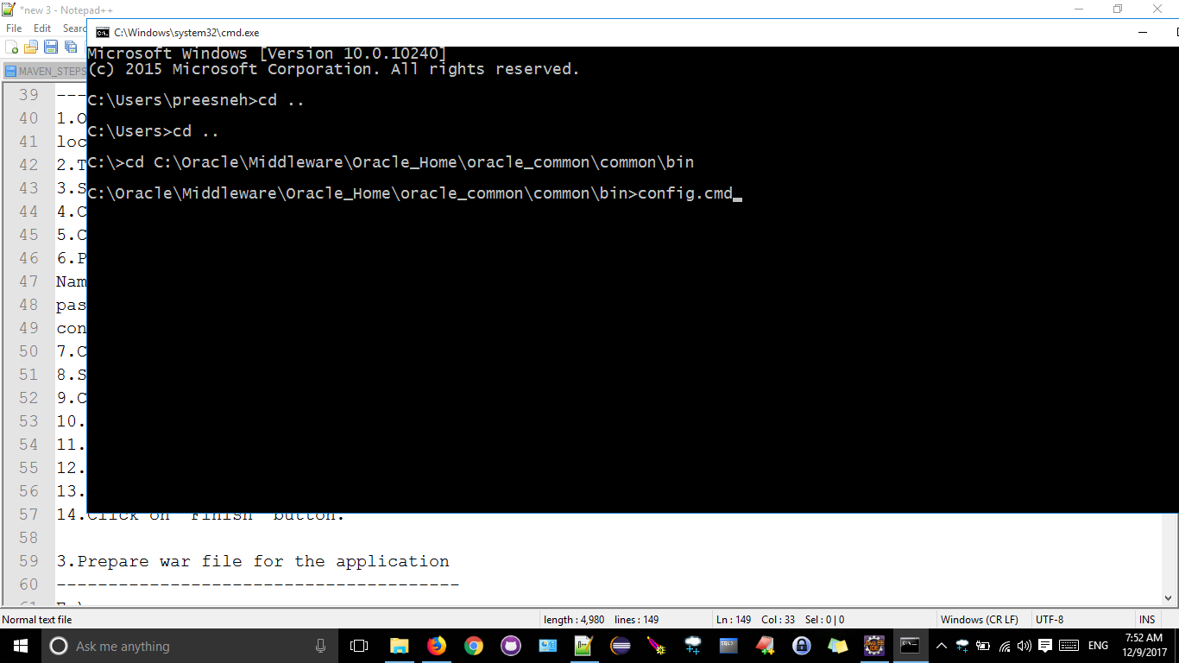

3.Select "Create New Domain" and Specify domain Name "durga_domain".
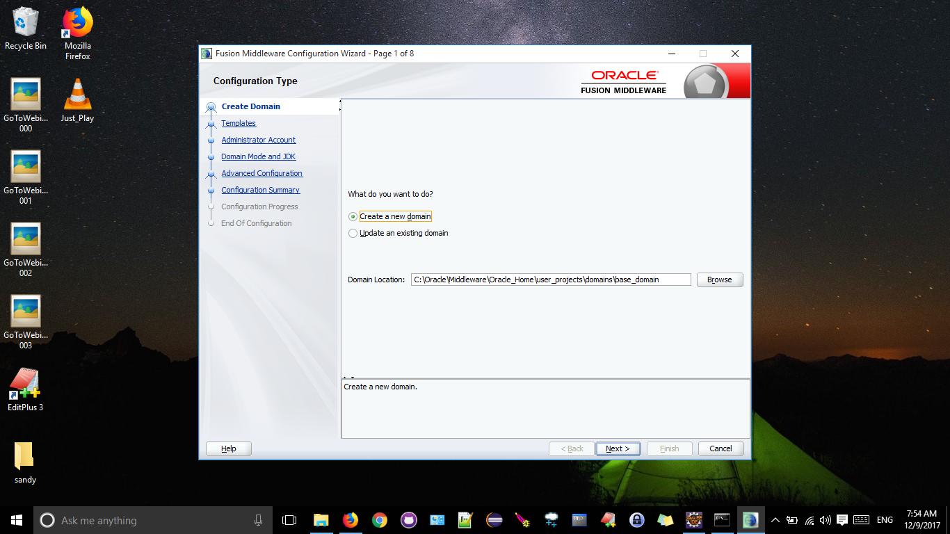

4.Click on "Next" button.
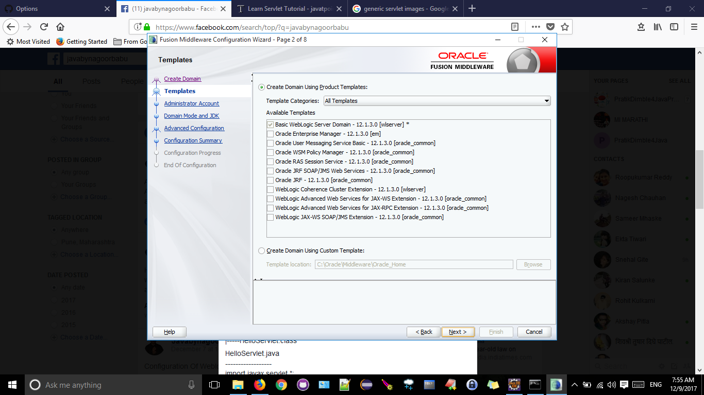

5.Click on "Next" button.

6.Provide the following details.
Name : weblogic
password: weblogic_weblogic
confirm Password: weblogic_weblogic
7.Click on "Next" button.
8.Specify Either Oracle Hotspot or our own JDK[C:=Java\jdk1.8.0".
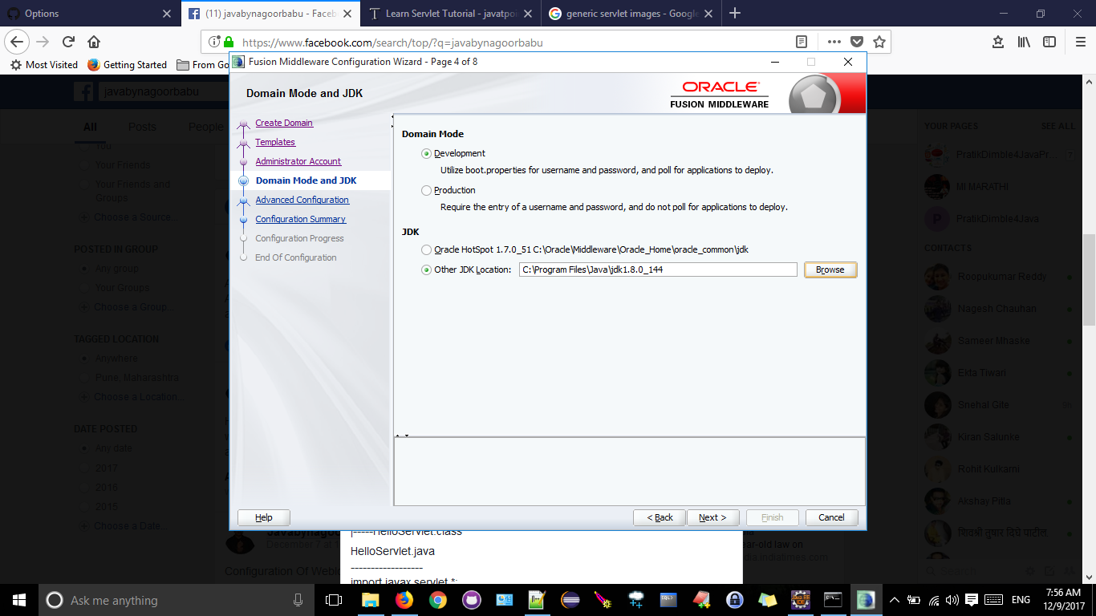

9.Click on "Next" button.
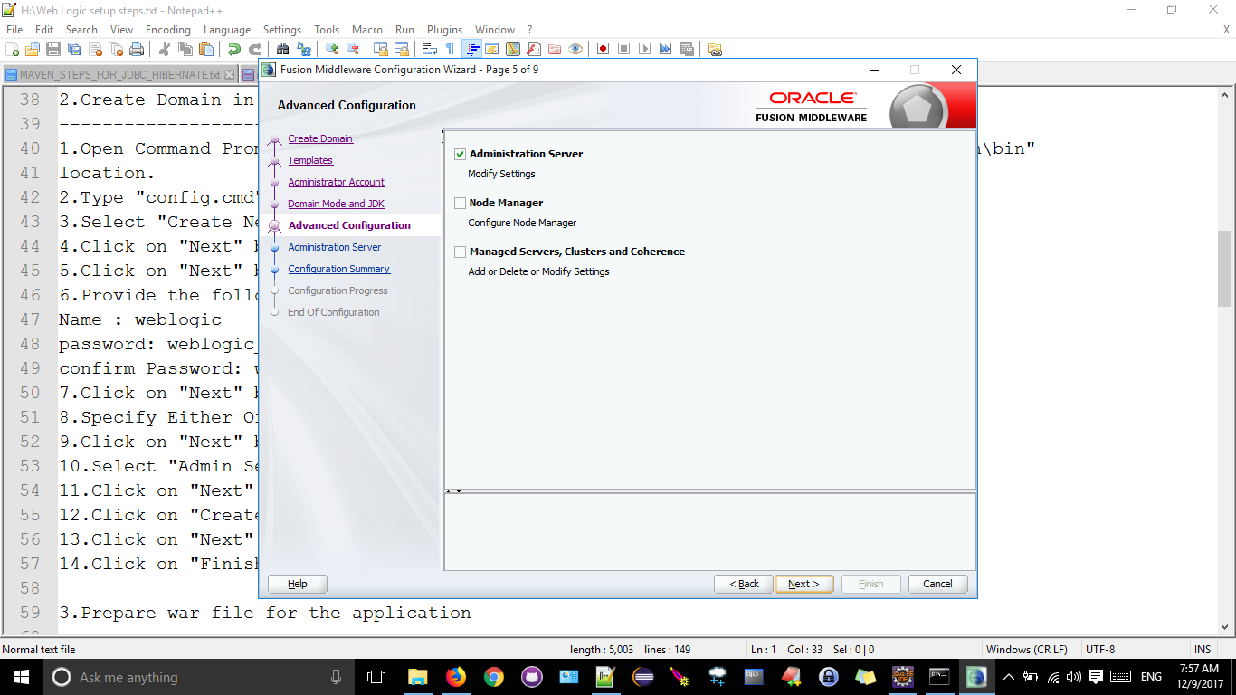

10.Select "Admin Server" and click on "Next" button.
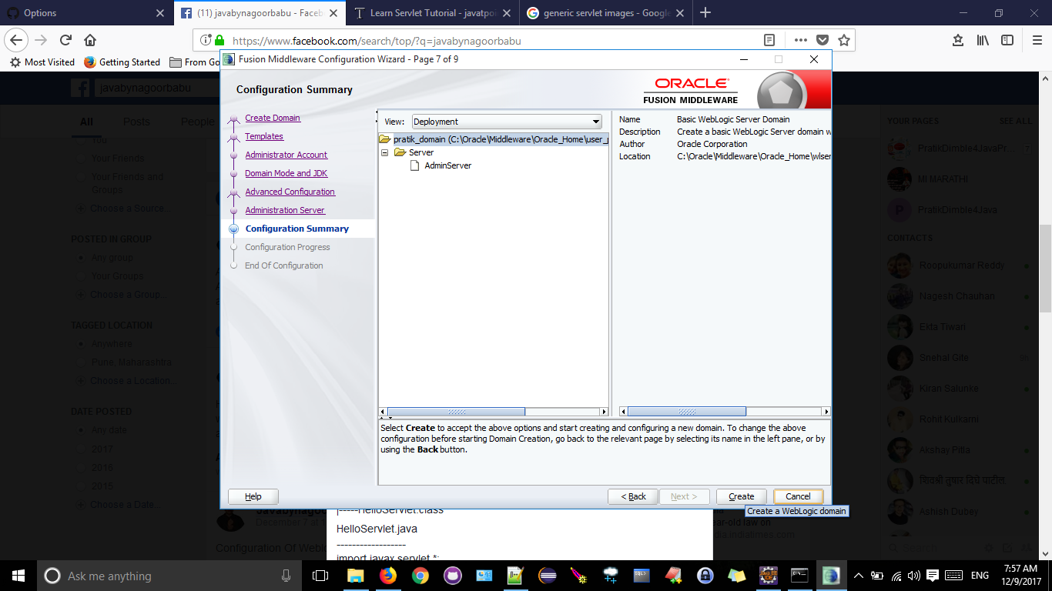

11.Click on "Next" button.
12.Click on "Create" button.

13.Click on "Next" button.
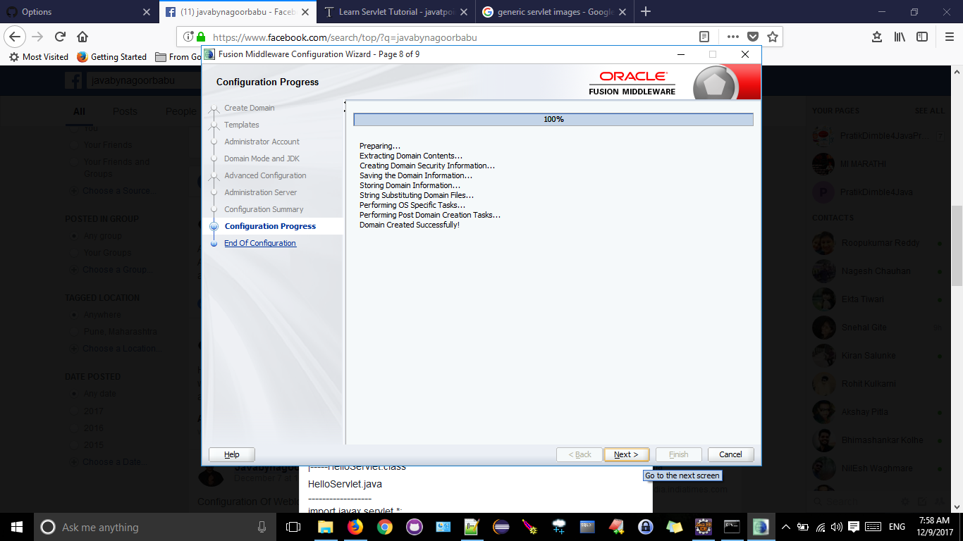

14.Click on "Finish" button.
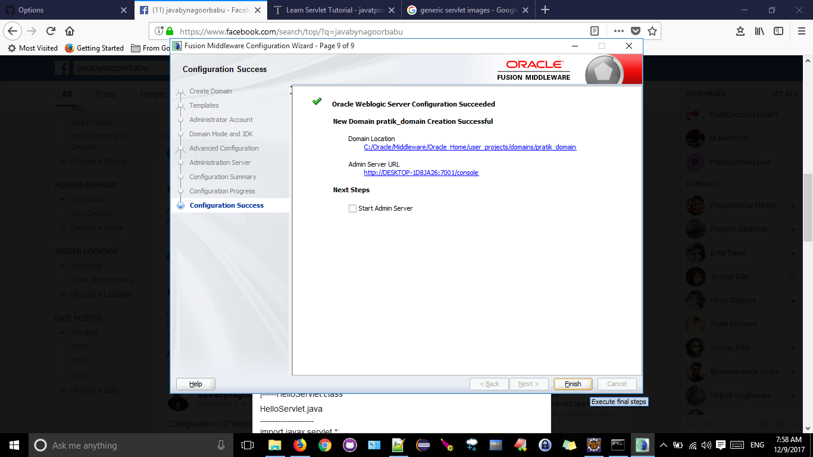

3.Prepare war file for the application
---------------------------------------
E:\myapps
---------
helloapp
|
|-----WEB-INF
| |-----web.xml
|-----classes
| |-----HelloServlet.java
|-----HelloServlet.class

HelloServlet.java
------------------
import javax.servlet.*;
import javax.servlet.http.*;
import java.io.*;
public class HelloServlet extends HttpServlet
{
public void doGet(HttpServletRequest request, HttpServletResponse response)throws
ServletException, IOException
{
response.setContentType("text/html");
PrintWriter out = response.getWriter();
out.println("<h1>Hello</h1>");
}
}

web.xml
--------
<web-app>
<servlet>
<servlet-name>helloServlet</servlet-name>
<servlet-class>HelloServlet</servlet-class>
</servlet>
<servlet-mapping>
<servlet-name>helloServlet</servlet-name>
<url-pattern>/hello</url-pattern>
</servlet-mapping>
</web-app>

E:\myapps\helloapp\WEB-INF\classes>set path=c:\java\jdk1.8.0\bin;
E:\myapps\helloapp\WEB-INF\classes>set classpath=C:\Oracle\Middleware\Oracle_Home\wlserver
\server\lib\weblogic.jar;

E:\myapps\helloapp\WEB-INF\classes>javac HelloServlet.java

3)Prepare war for the web application
--------------------------------------
E:\myapps\helloapp>jar -cvf helloapp.war *.*

4)Start Weblogic server and open administration console
-------------------------------------------------------
1.Goto C:\Oracle\Middleware\Oracle_Home\user_projects\domains\durga_domain .
2.Double click on "startWeblogic" batch file.

With the above steps , weblogic server will start.

To open Administration console we have to use the following steps.

1.Open Browser
2.Type "http://localhost:7001/console" on address bar
3.Provide the following details
user name: weblogic
password : weblogic_weblogic
4.Click on "Login" button
With the above steps Weblogic server will open "Administration page" or Home Page of the web
logic server.

5.upload war file to weblogic server
------------------------------------
1.Goto "Your deployed resources" section in Home Page and select
"Deployments" hyperlink.
2.Click on "install" button
3.select "upload your files" hyperlink
4.Click on "Browse" button in "Deployment" Archive section
5.Select war file and Click on "Open" button
6.Click on "Next" button
7.Click on "Next" button
8.Click on "Next" button
9.Click on "Next" button
10.Click on "Finish" button

6.Access web application
-------------------------
1.Click on "Testing" tab
2.Select "http://127.0.0.1:7001/helloapp" test point
3.Provide url pattern on address bar
http://127.0.0.1:7001/testapp/hello.

We will get Response on Browser.

